Exercise 1: Setting Up JUnit

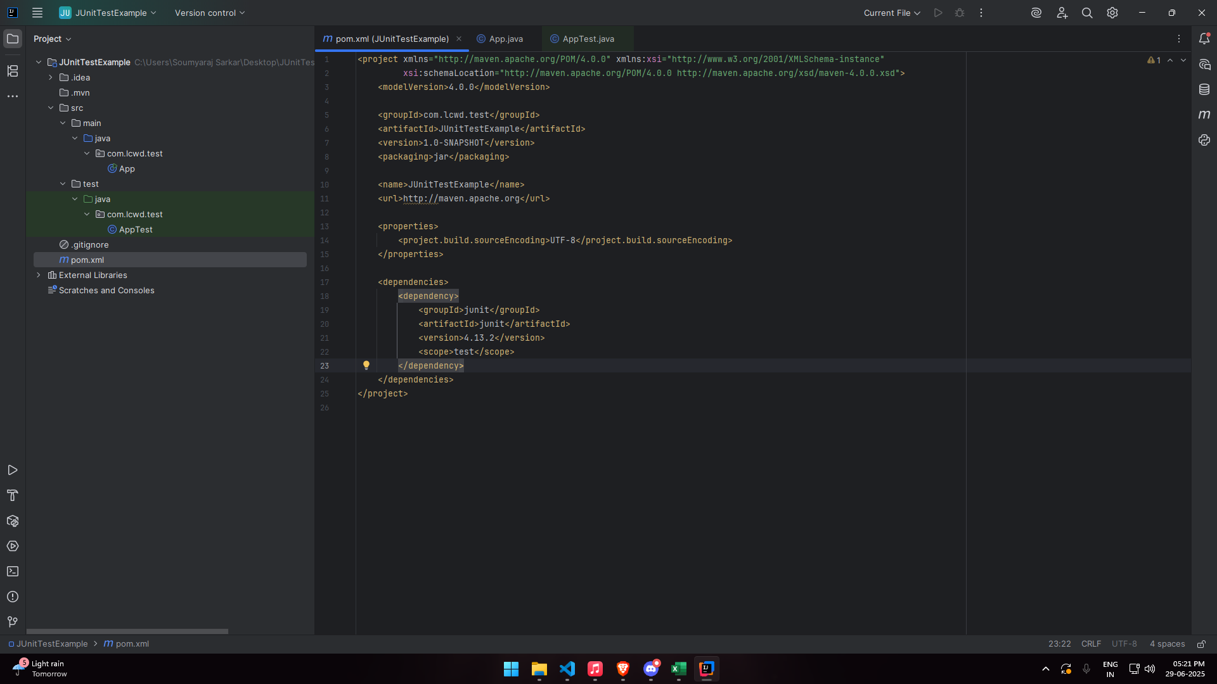

Exercise 3: Assertions in JUnit

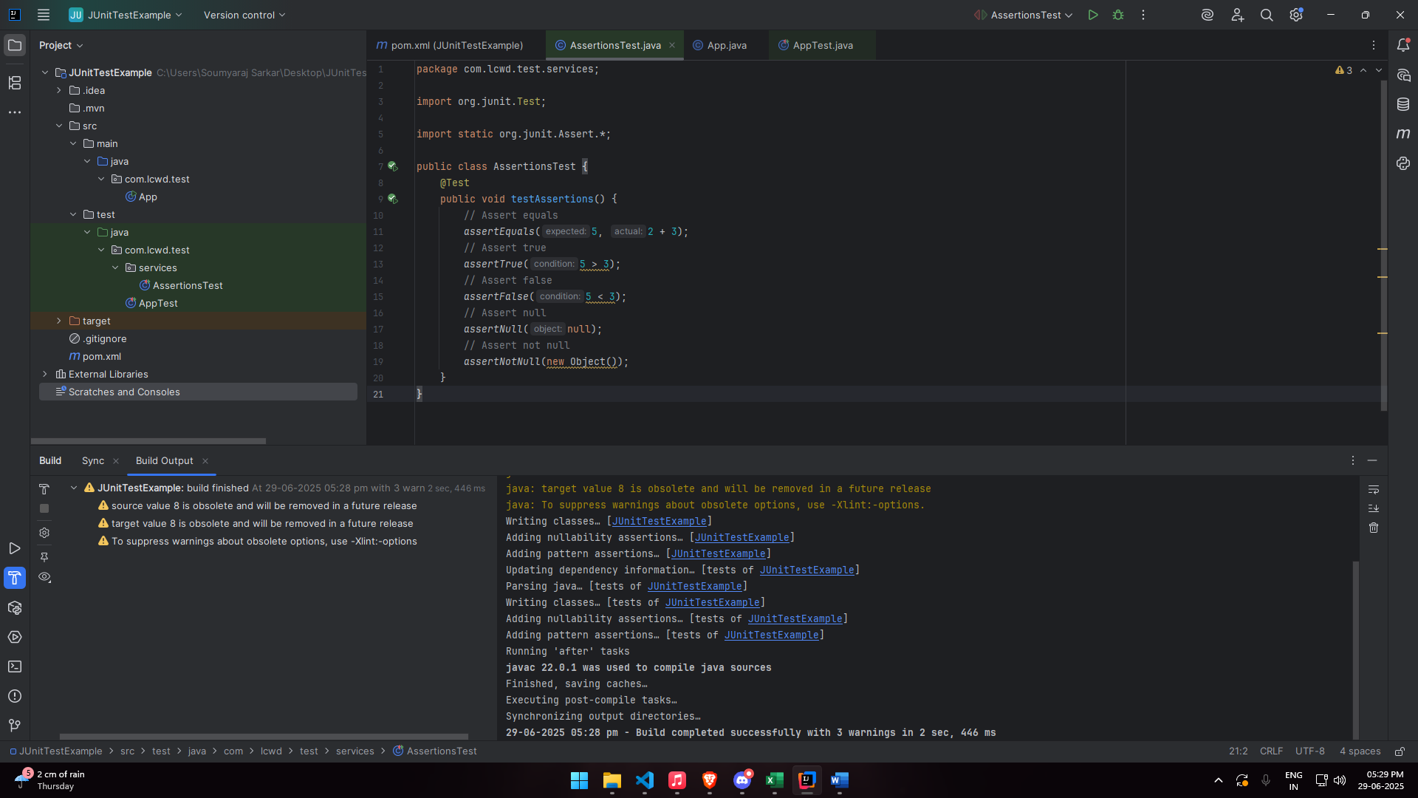

Exercise 4: Arrange-Act-Assert (AAA) Pattern, Test Fixtures, Setup and Teardown Methods in JUnit

